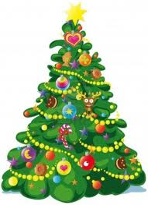

Vista Heights Middle School

Presents

Sounds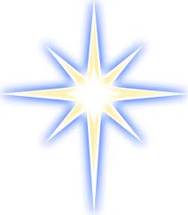

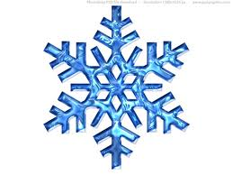of the

Season

Featuring

Drum Line

Pony Band

Concert Band

Percussion

Beginning Band

Symphonic Band

**7:30 Concert**

Pre-Concert (Beginning at 7:25)

***Beginning Percussion***

Jolly Old St. Nick………………………Chris Crockarell

Jingled Bells……………………..……..Chris Crockarell

***Beginning Band***

*(Conducted by Mrs. Rebecca Jensen)*

Up on the Housetop……………………..….Michael Story

Winter Wonderland………………….…..Robert W. Smith

*(Conducted by Mr. Lemen)*

African Pat-a-Pan……………….…………..Michael Story

We Wish You a Merry Christmas……….Robert W. Smith

***Symphonic Band***

Encanto……………………………..……Robert W. Smith

Greensleeves………………………..……Arr. Alfred Reed

A Visit From St. Nicholas……………….…….Len Orcino

*Narration by Mrs. Kelli Eisenhart*

*The Vista Heights Band would like to thank the faculty, staff and administration at Vista Heights for their continued support. Mostly, we would like to thank our parents for your love, support and encouragement.*

**6:30 Concert**

Pre-Concert (Beginning at 6:25)

***VHMS Drum Line***

Boogie

Earthquake……….…………………………Cassidy Byers

Pro Jam……………….…………………….Cassidy Byers

***Pony Band Level 1***

*(Directed by Mr. Chris Nelson)*

Jingle Bells

Up on the Housetop……………………….Michael Story

***Pony Band Level 2***

*(Directed by Mr. Eldon Carbine)*

We Wish You a Merry Christmas….……Robert W. Smith

African Pat-a-Pan……………………..…….Michael Story

Who Let the Elves Out?..................................Victor Lopez

***Concert Band***

Victorian Christmas……………………...Aric Branchfield

Jingle Bones……………………………….Andrew Glover

Fum, Fum, Fum…………………………….Michael Story